Ok we’re going to move away from 2D things to 3D!

Take the polygon you made during Day 2 and we’re going to extrude it

First you’re going to hit Finish Sketch

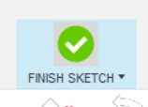

Now hit extrude



This will turn whatever your initial sketch was into a solid object

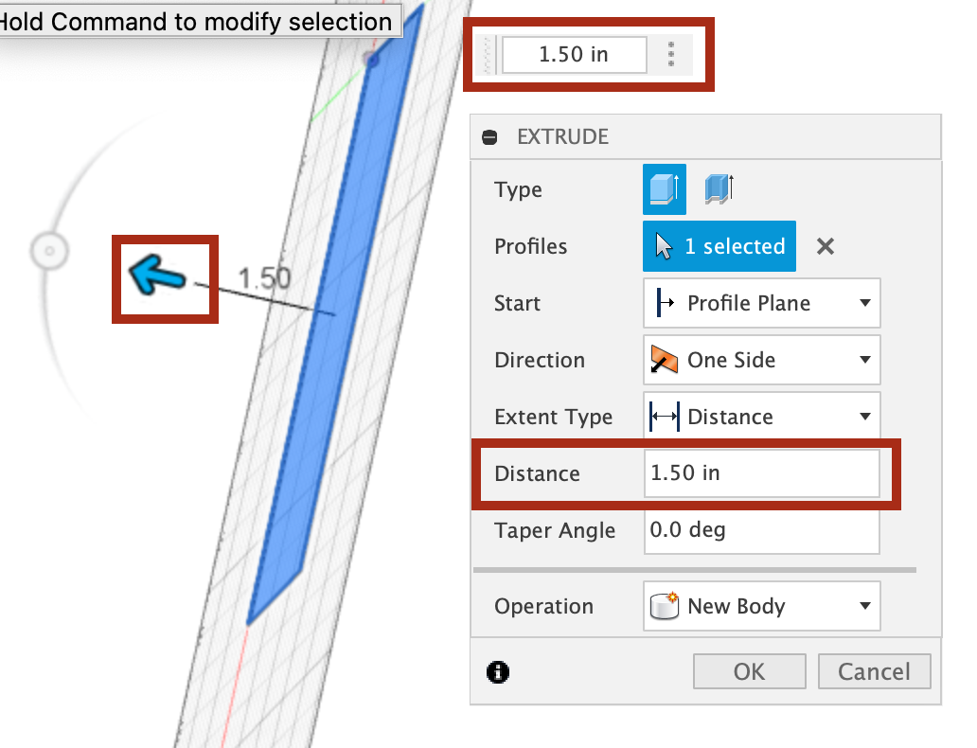

Drag the blue arrow or type the distance in either of the two boxes

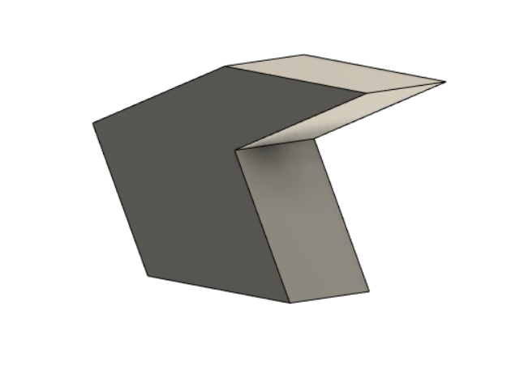

I extruded mine 40 inches and it made this!

Alright we’re going to play with removing now

Make a sketch on the side of your polygon- I’m making a triangle

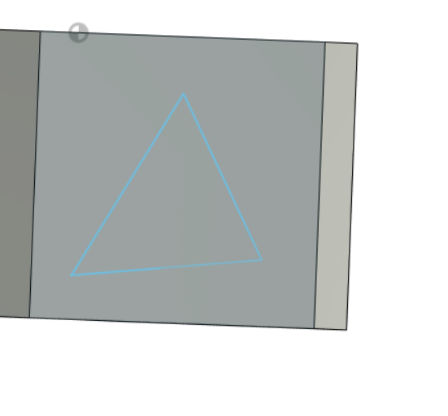

Okay now we’re going to constrain it

We’re going to start by making some construction lines

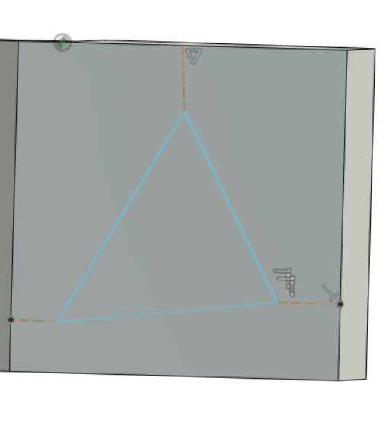

How you do this: make lines as usual then go to the “sketch palette” on the very right and click construction

Construction lines: help you constrian and do things in relation to other things

They just can’t define an area

* So you can’t make a shape with it and extrude it

Okay ! I want you to figure out how I constrained it! And do it yourself

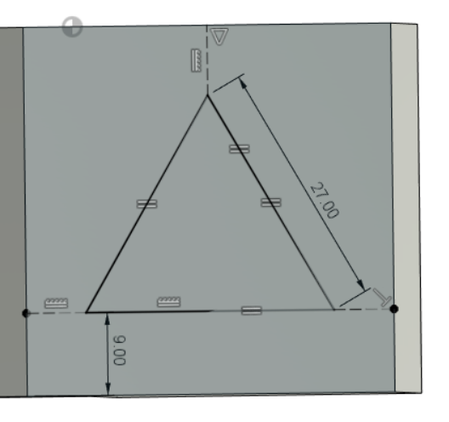

Alright now you can finish sketch

Now we’re gonna cut it out of the shape using extrude but you’re going to press the arrow the other way or enter any negative dimension

* Dig in as much as you want
* You’ll get something like this

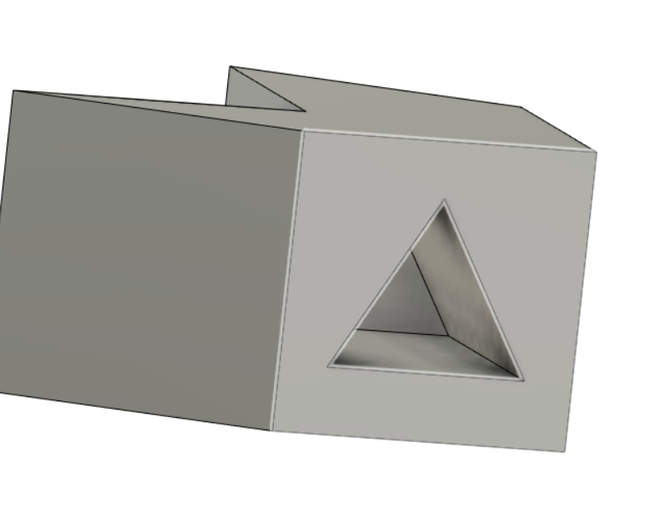

Alright! Now make another shape and extrude it out!

Here’s what mine looks like  
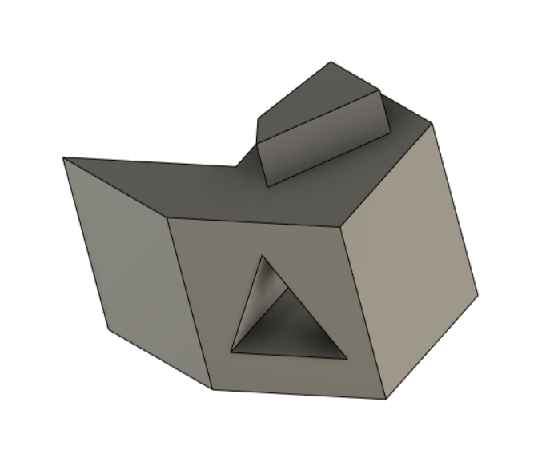

If you’re having trouble: you probably entered into the 3D sketch realm! Which is cool!

There’ll be another tutorial on that coming soon!

Okay! Day 4!